“Design and Development of an Linux File System Explorer Using System Calls”
A Project Report Submitted in the partial fulfillment of the requirements for the award of the degree of

BACHELOR OF TECHNOLOGY
In

DEPARTMENT OF COMPUTER SCIENCE ENGINNERING

By

K . Usharani 2520090049

K . Mrudula 2520090073

B . Koumudi 2520090161

Under the Esteemed Guidance of

Dr. M . Ragupathi
Assistant Professor
Department of Computer Science and Engineering




K L (Deemed to be) University DEPARTMENT OF COMPUTER SCIENCE ENGINEERING
&

DEPARTMENT OF COMPUTER SCIENCE AND INFORMATION TECHNOL

Declaration

The Project Report entitled “Design and Development of an Linux File System Explorer Using System Calls” is a record of Bonafide work of K . Usharani - 2520090049 , K . Mrudula - 2520090073, B . Koumudi - 2520090161 submitted in
partial fulfillment for the award of B. Tech in Computer Science and Engineering (or) Computer Science and Information Technology to the K L University. The results embodied in this report have not been copied from any other departments/University/Institute.

K . Usharani 2520090049

K . Mrudula 2520090073

B . Koumudi 2520090161

K L (Deemed to be) University

DEPARTMENT OF COMPUTER SCIENCE ENGINEERING

CERTIFICATE

This is certify that the mini project based report entitled “Design and Development of an Linux File System Explorer Using System Calls” is a bonafide work done and submitted by
K . Usharani – 2520090049, K . Mrudula – 2520090073, B . Koumudi - 2520090161
in partial fulfillment of the requirements for the award of the degree of BACHELOR OF TECHNOLOGY in Department of Computer Science & Information Technology K L (Deemed to be University), during the academic year 2026-2027.

Signature of the Guide

Signature of the Course Coordinator Signature of the HOD

ACKNOWLEDGEMENT
The success in this project would not have been possible but for the timely help and guidance rendered by many people. Our wish to express my sincere thanks to all those who has assisted us in one way or the other for the completion of my project.

Our greatest appreciation to my Course Coordinator Dr. K. Anusha, and my guide Dr. M. Ragupathi, Department of Computer Science which cannot be expressed in words for his/her tremendous support, encouragement and guidance for this project.

We express our gratitude to Dr. P Venkateshwara Roa (CSE), Head of the Department for Computer Science Engineering for providing us with adequate facilities, ways and means by which we are able to complete this project-based Lab.

We thank all the members of teaching and non-teaching staff members, and also who have assisted me directly or indirectly for successful completion of this project. Finally, I sincerely thank my parents, friends and classmates for their kind help and cooperation during my work.

K . Usharani 2520090049

K . Mrudula 2520090073

B . Koumudi 2520090161
Abstract

The global travel and tourism sector is experiencing rapid growth, but planning a trip remains complex, forcing travellers to use multiple different apps for flights, trains, and hotels. This fragmented approach causes delays, confusion, and a poor user experience. To tackle this, our project focuses on the Design and Development of an Integrated Tourism Platform for Flights, Trains, Hotels, and Hidden Destinations. Our core aim was to successfully implement a unified, single-window website that dramatically simplifies the entire travel process for the modern global traveller.

The platform is structured around four primary, fully interconnected modules. It offers seamless booking for Flights (with real-time fares and availability, including the critical function to compare and sort packages from cheapest to highest) and Hotels (with a vast inventory, user reviews, and similar pricing comparison tools). Crucially, the platform includes a comprehensive Train Ticket Module with essential functionalities like live running status and PNR checks, addressing the high demand for rail travel information within the region.

The most innovative feature is the dedicated Hidden Destinations Discovery Module. This system uses smart recommendations to suggest off-beat, lesser-known, and culturally rich locations globally. By promoting these hidden gems, we are not only enriching the user's journey but also supporting local communities and encouraging more sustainable and diversified tourism. The system is built using robust, modern web technologies and is fully responsive across all devices. In summary, this project delivers a complete, reliable, and user-friendly digital solution that significantly enhances the experience of planning, booking, and exploring travel worldwide.

Index

S. No. | Chapter | Topics / Subtopics | Page No.
 | Acknowledgement |  | i
 | Abstract |  | ii
1 | Introduction |  | 1–5
 |  | 1.1 Background of the Project
 |  | 1.2 Problem Statement
 |  | 1.3 Scope of the Project
 |  | 1.4 Objectives of the Project
 |  | 1.5 Importance of the Application
 |  | 1.6 Target Users / Audience
2 | OS Concepts and Background Study |  | 6–12
 |  | 2.1 Operating System Concepts Related to the Project
 |  | 2.2 Existing Methods / Algorithms
 |  | 2.3 Proposed Approach
 |  | 2.4 Advantages of the Proposed Approach
3 | System Requirements |  | 13–17
 |  | 3.1 Hardware Requirements
 |  | 3.2 Software Requirements
 |  | 3.3 Operating System Environment – Ubuntu / WSL
 |  | 3.4 Development Tools and Compilers
4 | Technology and Tools Used |  | 18–22
 |  | 4.1 C / C++ Programming
 |  | 4.2 GCC Compiler
 |  | 4.3 Linux System Calls
 |  | 4.4 POSIX Threads / Synchronization
 |  | 4.5 Linux Commands and Utilities
 |  | 4.6 Other Tools / Libraries Used
5 | System Architecture and Design |  | 23–29
 |  | 5.1 Overall System Architecture
 |  | 5.2System Workflow
 |  | 5.3 Flowchart / Data Flow
 |  | 5.4 Module Description
 |  | 5.5 Input and Output Design
6 | Implementation |  | 30–45
 |  | 6.1 Module-wise Implementation
 |  | 6.2 Algorithm / Pseudocode
 |  | 6.3 Core C / C++ Implementation
 |  | 6.4 Linux System Calls / APIs Used
 |  | 6.5 Process / Thread Implementation
 |  | 6.6 IPC / Synchronization Implementation
 |  | 6.7 Memory Management Implementation
 |  | 6.8 Optional User Interface Implementation
7 | Execution and Demonstration |  | 62–67
 |  | 7.1 Compilation in Ubuntu
 |  | 7.2 Execution Commands
 |  | 7.3 Sample Inputs and Outputs
 |  | 7.4 Screenshots of Execution
 |  | 7.5 Demonstration of OS Concepts
8 | Conclusion |  | 79–83
 |  | 8.1 Summary of the Project
 |  | 8.2 Objectives Achieved
 |  | 8.3 Results Achieved
 |  | 8.4 Skills and Learning Outcomes
9 | References |  | 84–86
 |  | 9.1 Books
 |  | 9.2 Research Papers
 |  | 9.3 Linux / GNU Documentation
 |  | 9.4 Online Resources

CHAPTER -1 INTRODUCTION

1.1 Background of the Project

A file system is an essential component of an operating system that organizes, stores, and manages files and directories. Linux provides several system calls that allow applications to directly interact with the file system. Understanding these system calls is important for learning how operating systems perform file and directory operations at a low level.

The Linux File System Explorer Using System Calls project is a menu-driven C application developed to demonstrate common Linux file-system operations. The application allows users to create, write, read, delete, rename, and obtain information about files, along with creating, removing, listing, and changing directories. It also provides recursive file searching. The project uses Linux/POSIX system calls such as open(), read(), write(), close(), unlink(), rename(), stat(), mkdir(), rmdir(), chdir(), and directory-handling functions.

1.2 Problem Statement
Learning Linux file-system operations only through theoretical concepts can make it difficult to understand how applications interact with the operating system. Beginners need a practical way to observe the working of system calls and understand how files, directories, permissions, and file information are handled.
The proposed project addresses this problem by providing a single menu-driven application that demonstrates multiple file-system operations through actual Linux system calls. It also includes recursive searching and error handling for invalid file or directory operations.

1.3 Scope of the Project
The scope of the project includes:
- Creating, reading, writing, deleting, and renaming files.
- Creating, removing, listing, and changing directories.
- Displaying file information using stat().
- Searching for files recursively inside directories.
- Demonstrating Linux/POSIX system calls.
- Handling common file and directory errors.
- Providing a command-line interface for performing operations.
- Running and testing the application in Ubuntu/WSL.

1.4 Objectives of the Project
The main objectives are:
- To develop a functional Linux file-system explorer using C.
- To demonstrate practical usage of Linux/POSIX system calls.
- To perform common file and directory operations.
- To implement recursive file searching.
- To display file metadata and permissions.
- To implement appropriate error handling.
- To provide hands-on understanding of operating-system file-system concepts.
- To test and validate the implemented operations using multiple test cases.

1.5 Importance of the Application
This project provides practical understanding of how applications interact with the Linux file system through system calls. It connects operating-system theory with actual implementation and helps students understand concepts such as file descriptors, directories, file metadata, permissions, and system-level file operations.
The application can also be used as an educational tool for demonstrating Linux system programming and operating-system concepts in a practical environment.

1.6 Target Users / Audience
The primary users of this project are:
- Students learning Operating Systems and System Programming.
- Beginners learning Linux/POSIX system calls.
- Developers interested in basic Linux file-system programming.
- Instructors demonstrating file-system concepts and system calls.

CHAPTER -2 OS Concepts and background Study

2.1 Operating System Concepts Related to the Project

The project is based on Linux operating-system concepts related to file systems and system calls. The Linux file system organizes information into files and directories, while system calls provide the interface through which applications request services from the operating system.

The major concepts demonstrated in this project are:

System Calls: Used to perform file and directory operations.

File Descriptors: Used to identify and access opened files.

Files: Created, read, written, renamed, and deleted by the application.

Directories: Created, removed, listed, and navigated using directory operations.

File Metadata: Obtained using the stat() system call, including file size, ownership, permissions, and modification information.

Directory Traversal: Used for recursively searching files within directories.

Error Handling: System errors are handled using appropriate error-reporting mechanisms such as perror().

2.2 Existing Methods / Approaches

Normally, Linux file-system operations can be performed directly using standard Linux commands such as:

ls — list files and directories

cat — display file contents

touch — create files

mkdir — create directories

rm — delete files

mv — rename or move files

cd — change directories

find — search for files

However, using these commands does not directly demonstrate how applications perform these operations internally through system calls.

2.3 Proposed Approach

The proposed approach is to develop a menu-driven Linux File System Explorer in C that directly uses Linux/POSIX system calls for common file and directory operations.

The application provides a single interface through which the user can:

Show the current directory.

List files and directories.

Create a file.

Write to a file.

Read a file.

Delete a file.

Rename a file.

Display file information.

Create a directory.

Remove a directory.

Change the current directory.

Search for a file recursively.

Exit the application.

2.4 Advantages of the Proposed Approach

The proposed approach provides the following advantages:

Provides practical understanding of Linux system calls.

Combines multiple file-system operations in one application.

Demonstrates direct interaction between an application and the Linux file system.

Provides recursive file-search functionality.

Displays file metadata using stat().

Includes error handling for invalid operations.

Provides a simple menu-driven interface.

Helps connect Operating System theory with practical implementation.

Can be compiled and executed easily using GCC in Ubuntu/WSL.

CHAPTER 3 – SYATEM REQUIREMENTS

3.1 Hardware Requirements

The project does not require any specialized hardware. A standard computer system is sufficient.

Minimum requirements:

Processor: Intel/AMD processor

RAM: 4 GB or above

Storage: At least 500 MB free space

Keyboard and monitor

Internet connection for downloading required software and maintaining the GitHub repository

3.2 Software Requirements

The following software is required:

Operating System: Ubuntu Linux / Windows with WSL

Programming Language: C

Compiler: GCC

Build Tool: GNU Make

Terminal: Ubuntu Terminal

Code Editor: Visual Studio Code

Version Control: Git

Repository: GitHub

3.3 Operating System Environment – Ubuntu / WSL

The project is developed and tested in an Ubuntu environment using Windows Subsystem for Linux (WSL). WSL provides a Linux environment on Windows, allowing the project to use Linux commands, system calls, file-system operations, GCC, and Make.

The application is executed through the Ubuntu terminal, where users can interact with the menu-driven explorer and perform file and directory operations.

3.4 Development Tools and Compilers

GCC Compiler

GCC is used to compile the C source files into an executable program.

Example:

gcc -Wall -Wextra -std=c11 main.c file_operations.c directory_operations.c file_info.c search.c -o explorer

GNU Make

A Makefile is provided to simplify compilation and rebuilding of the project.

make

Visual Studio Code

Visual Studio Code is used to write, organize, and modify the project's C source files.

Git and GitHub

Git is used for version control, while GitHub is used to store and maintain the project repository and its documentation.

CHAPTER 4 — TECHNOLOGY AND TOOLS USED

4.1 C Programming

The project is developed using the C programming language. C provides low-level access to operating-system functionality and is suitable for implementing Linux system calls. The application is divided into separate source files for file operations, directory operations, file information, searching, and menu control.

4.2 GCC Compiler

GNU Compiler Collection (GCC) is used to compile the C source files and generate the executable file. Compilation is performed with warning and C11 standard options to improve code reliability.

gcc -Wall -Wextra -std=c11 main.c file_operations.c directory_operations.c file_info.c search.c -o explorer

4.3 Linux System Calls

Linux/POSIX system calls form the core of the project. The major calls and APIs used are:
System Call / API | Purpose
open() | Create or open a file
read() | Read file contents
write() | Write data to a file
close() | Close an opened file
unlink() | Delete a file
rename() | Rename a file
getcwd() | Get the current working directory
opendir() | Open a directory
readdir() | Read directory entries
closedir() | Close a directory
mkdir() | Create a directory
rmdir() | Remove a directory
chdir() | Change the current directory
stat() | Obtain file information
perror() | Display system error information

4.4 Linux Commands and Utilities

The project is developed and executed using the Ubuntu terminal. Linux commands and utilities are used for navigating directories, compiling the source code, building the application, and executing the generated program.

Important commands include:

make

make clean

ls

cd

pwd

./explorer

4.5 Makefile

A Makefile is included to automate the compilation process. It allows the complete project to be built using:

make

The compiled executable is generated as:

explorer

4.6 Git and GitHub

Git is used for version control and tracking project changes. GitHub is used as the remote repository for storing the source code, documentation, test results, and other project materials.

CHAPTER 5 — SYSTEM ARCHITECTURE AND DESIGN

5.1 Overall System Architecture

The Linux File System Explorer Using System Calls follows a modular architecture in which the main program controls the user interaction and separate modules perform file, directory, file-information, and search operations.

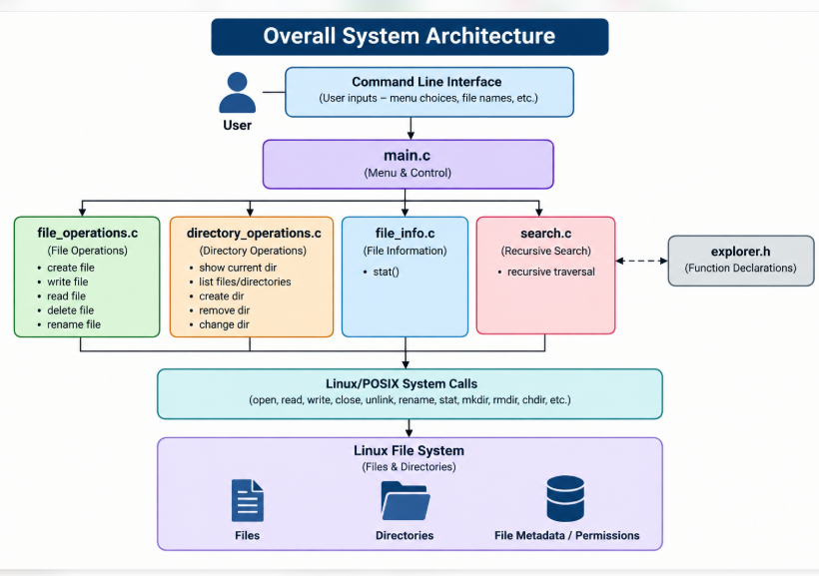

The explorer.h header file contains the function declarations shared between the modules, while the Makefile is used to compile all source files into the final executable.

5.2 System Workflow

The system follows a menu-driven workflow. The user selects an operation, and the corresponding module performs the required operation using Linux system calls.

The major workflow stages are:

The program starts and displays the main menu.

The user selects an operation.

main.c identifies the selected operation.

The appropriate module function is called.

The module performs the operation using Linux system calls.

The result or error message is displayed.

The program returns to the main menu.

The program terminates when the user selects Exit.

5.3 Flowchart and Data Flow

5.4 Module Description

Module | File | Main Responsibility
Main control | main.c | Displays menu and control program execution
File Operations | file_operations.c | Create, read, write, delete, and rename files
Directory Operations | directory_operations.c | Create, remove, list and change directories
File Information | file_info.c | Display file metadata using stat()
Search | Search.c | Perform recursive file searching
Header | Explorer.h | Contains function declarations
Build | Makefile | Compiles the complete project

main.c is responsible for displaying the menu and accepting the user's choice. Based on the selected option, it calls the required function from the appropriate module.

5.4.2 File Operations Module

file_operations.c handles operations related to files, including:

Creating a file

Writing data to a file

Reading file contents

Deleting a file

Renaming a file

Linux system calls such as open(), read(), write(), close(), unlink(), and rename() are used.

5.4.3 Directory Operations Module

directory_operations.c manages directories and provides functions for:

Showing the current directory

Listing files and directories

Creating a directory

Removing a directory

Changing the current directory

The module uses functions such as getcwd(), opendir(), readdir(), closedir(), mkdir(), rmdir(), and chdir().

5.4.4 File Information Module

file_info.c displays information about a selected file using the stat() system call. The information includes properties such as file size, user/group identifiers, permissions, and modification information.

5.4.5 Search Module

search.c performs recursive file searching. It starts from the selected directory, examines its contents, and enters subdirectories when required. This allows the program to locate files inside nested directories.

5.5 Input and Output Design

5.6 Summary of Architecture

The architecture separates user interaction from individual file-system operations. This modular design makes the program easier to understand, test, maintain, and extend. Each module has a specific responsibility while Linux system calls provide the actual interaction with the file system.

CHAPTER 6 — IMPLEMENTATION

6.1 Module-Wise Implementation

The Linux File System Explorer is implemented using the C programming language. The project is divided into separate modules, with each module responsible for a specific operation.

1. Main Control Module (main.c)

Displays the menu to the user.

Accepts the user's choice.

Calls the appropriate function.

Controls program execution until the user selects Exit.

2. File Operations Module (file_operations.c)

Implements the following operations:

Create a file using open().

Write content using write().

Read content using read().

Delete a file using unlink().

Rename a file using rename().

3. Directory Operations Module (directory_operations.c)

Implements:

Display current directory.

List files and directories.

Create directories.

Remove directories.

Change the current directory.

4. File Information Module (file_info.c)

Uses the stat() function to retrieve file information such as file size, permissions, UID, GID, and modification time.

5. Search Module (search.c)

Implements recursive file searching by traversing directories and their subdirectories to locate the requested file.

6. Header File (explorer.h)

Contains function declarations required for communication between different source files.

6.2 Algorithm and Pseudocode

The project follows a menu-driven algorithm.

Algorithm: Linux File System Explorer

Start the program.

Display the main menu.

Accept the user's choice.

Check the selected option.

Call the corresponding function.

Perform the selected file or directory operation.

Display the result or error message.

Return to the main menu.

If the user selects Exit, terminate the program.

Stop.

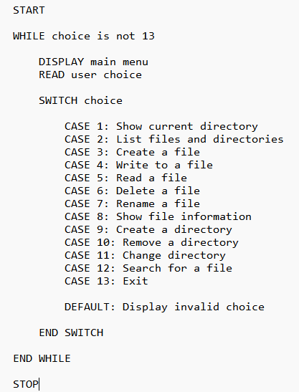

6.3 Core C Implementation

The project uses C functions and Linux system calls to perform file-system operations.

Example 1: Creating a File

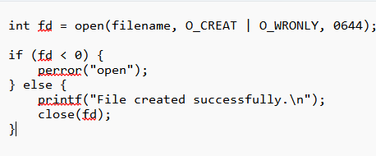

Example 2: Writing to a File

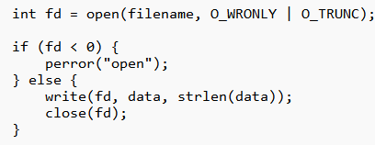

Example 3: Reading a File

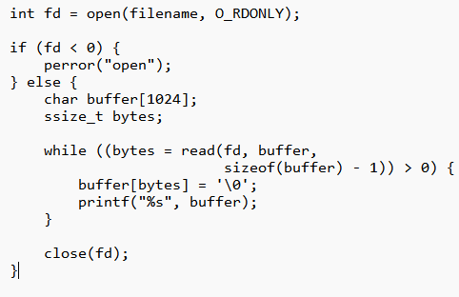

These examples illustrate the system-call approach used in the project. The complete implementation is divided across the individual source files.

6.4 Linux System Calls and APIs

The project uses Linux/POSIX system calls and library functions to interact with files and directories.
Function | Purpose
open() | Opens or creates a file
read() | Reads file content
write() | Writes data into a file
close() | Closes a file descriptor
unlink() | Deletes a file
rename() | Renames a file
getcwd() | Gets the current directory
opendir() | Opens a directory
readdir() | Reads directory entries
closedir() | Closes a directory
mkdir() | Creates a directory
rmdir() | Removes a directory
chdir() | Changes the current directory
stat() | Retrieves file information
perror() | Displays error messages

These functions provide the basic operations required for file and directory management.

6.5 Process and Thread Implementation

The Linux File System Explorer is implemented as a single-process, menu-driven application.

The program executes operations based on user input.

The main function controls the execution.

Different modules handle different operations.

No multithreading or parallel processing is implemented.

6.6 Inter-Process Communication and Synchronization

The project does not use Inter-Process Communication (IPC) or synchronization mechanisms because it does not involve multiple processes or concurrent threads.

Instead, the application performs file-system operations sequentially based on user selections.

6.7 Memory Management

The application uses variables and buffers to store user inputs, file names, and file contents during execution.

File descriptors returned by open() are closed using close() after the required operations. Directory streams opened using opendir() are closed using closedir().

This helps release the resources used during file and directory operations.

6.8 User Interface Implementation

The project provides a command-line menu interface that allows users to select and execute different file-system operations.

The main menu contains 13 options:

Show Current Directory

List Files and Directories

Create a File

Write to a File

Read a File

Delete a File

Rename a File

Show File Information

Create a Directory

Remove a Directory

Change Directory

Search for a File

Exit

The interface displays success messages when operations are completed and error messages when operations fail.

CHAPTER 7 — EXECUTION AND DEMONSTRATION

7.1 Compilation

The Linux File System Explorer is developed using the C programming language and compiled using the GCC compiler in the Ubuntu environment.

The project uses a Makefile to simplify the compilation process.

Compilation commands:

cd src

make clean

make

The make command compiles all the source files and generates the executable file named explorer.

7.2 Execution Commands

After successful compilation, the application can be executed using the following commands:

cd ../data

../src/explorer

The program starts and displays the main menu in the Ubuntu terminal.

To execute the program, users can select an operation by entering its corresponding number.

7.3 Sample Inputs and Outputs

The following examples demonstrate the working of the Linux File System Explorer.

1. Display Current Directory

Input:

Enter your choice: 1

Output:

Current Directory: /project/data

2. Create a File

Input:

Enter your choice: 3

Enter file name: test.txt

Output:

File created successfully.

3. Write to a File

Input:

Enter your choice: 4

Enter file name: test.txt

Enter content: Linux File System Explorer Test

Output:

Data written successfully.

4. Read a File

Input:

Enter your choice: 5

Enter file name: test.txt

Output:

Linux File System Explorer Test

5. Search for a File

Input:

Enter your choice: 12

Enter file name to search: nested.txt

Output:

File found: ./test_directory/nested.txt

6. Exit

Input:

Enter your choice: 13

Output:

Exiting Linux File System Explorer.

7.5 Operating System Concepts Demonstration

The project demonstrates important operating system concepts through practical implementation.
OS Concept | Demonstration
System Calls | Uses open(), read(), write(), and other functions
File Management | Creates, reads, writes, deletes, and renames files
Directory Management | Creates, removes, lists, and navigates directories
File Metadata | Retrieves information using stat()
File Descriptors | Uses file descriptors returned by open()
Error Handling | Displays errors using perror()
Directory Traversal | Searches files recursively through directories

The project provides practical knowledge of how applications interact with the Linux file system through system calls.

7.6 Testing Results

The application was tested using different file and directory operations.

A total of 14 test cases were performed.

Total Test Cases: 14

Passed: 14

Failed: 0

Success Rate: 100%

The testing results confirm that all the tested operations performed successfully.

7.7 Demonstration Summary

The Linux File System Explorer successfully demonstrates file management, directory management, file information retrieval, recursive searching, and error handling using Linux system calls.

CHAPTER 8 — CONCLUSION

8.1 Summary

The Linux File System Explorer Using System Calls is a C-based application developed to perform file and directory operations in a Linux environment.

The application provides a menu-driven interface that allows users to create, read, write, delete, and rename files. It also supports directory management, file information retrieval, and recursive file searching.

Linux/POSIX system calls are used to interact with the file system and perform the required operations.

8.2 Objectives Achieved

The project successfully achieves the following objectives:

Developed a menu-driven Linux File System Explorer.

Implemented file creation, reading, writing, deletion, and renaming.

Implemented directory creation, removal, listing, and navigation.

Retrieved file information using the stat() function.

Implemented recursive file searching.

Used Linux system calls for file-system operations.

Implemented basic error handling.

8.3 Results Achieved

The project was successfully compiled and executed in the Ubuntu environment.

The application performed the required file and directory operations successfully.

Testing Results:
Description | Result
Total Test Cases | 14
Passed | 14
Failed | 0
Success Rate | 100%

The testing results demonstrate that all 14 tested cases passed successfully.

8.4 Skills and Learning Outcomes

Through this project, we gained practical knowledge of:

C programming and modular programming.

Linux operating system concepts.

Linux/POSIX system calls.

File and directory management.

File descriptors and file metadata.

Recursive directory traversal.

Error handling and debugging.

Compilation using GCC and Makefile.

Project development using Git and GitHub.

The project helped us understand how user-level applications interact with the Linux operating system through system calls.

8.5 Future Enhancements

The project can be improved in the future by adding:

Graphical User Interface (GUI).

File permission modification.

File copying and moving operations.

File sorting and filtering.

File search by extension and file type.

File operation history and logging.

8.6 Final Conclusion

The Linux File System Explorer successfully demonstrates the practical use of Linux system calls for file and directory management. It provides a simple and effective way to understand operating system concepts through hands-on implementation in C.

CHAPTER 9 — REFERENCES

[1] W. Richard Stevens and Stephen A. Rago, Advanced Programming in the UNIX Environment, 3rd Edition, Addison-Wesley, 2013.

[2] Brian W. Kernighan and Dennis M. Ritchie, The C Programming Language, 2nd Edition, Prentice Hall, 1988.

[3] Linux Manual Pages, Linux System Calls Documentation.
https://man7.org/linux/man-pages/

[4] GNU Compiler Collection (GCC) Documentation.
https://gcc.gnu.org/documentation.html

[5] GNU Make Documentation.
https://www.gnu.org/software/make/manual/

[6] Ubuntu Official Documentation.
https://documentation.ubuntu.com/

[7] GitHub Documentation.
https://docs.github.com/

